Grain growth – user manual

After starting the application, the user interface will be displayed.
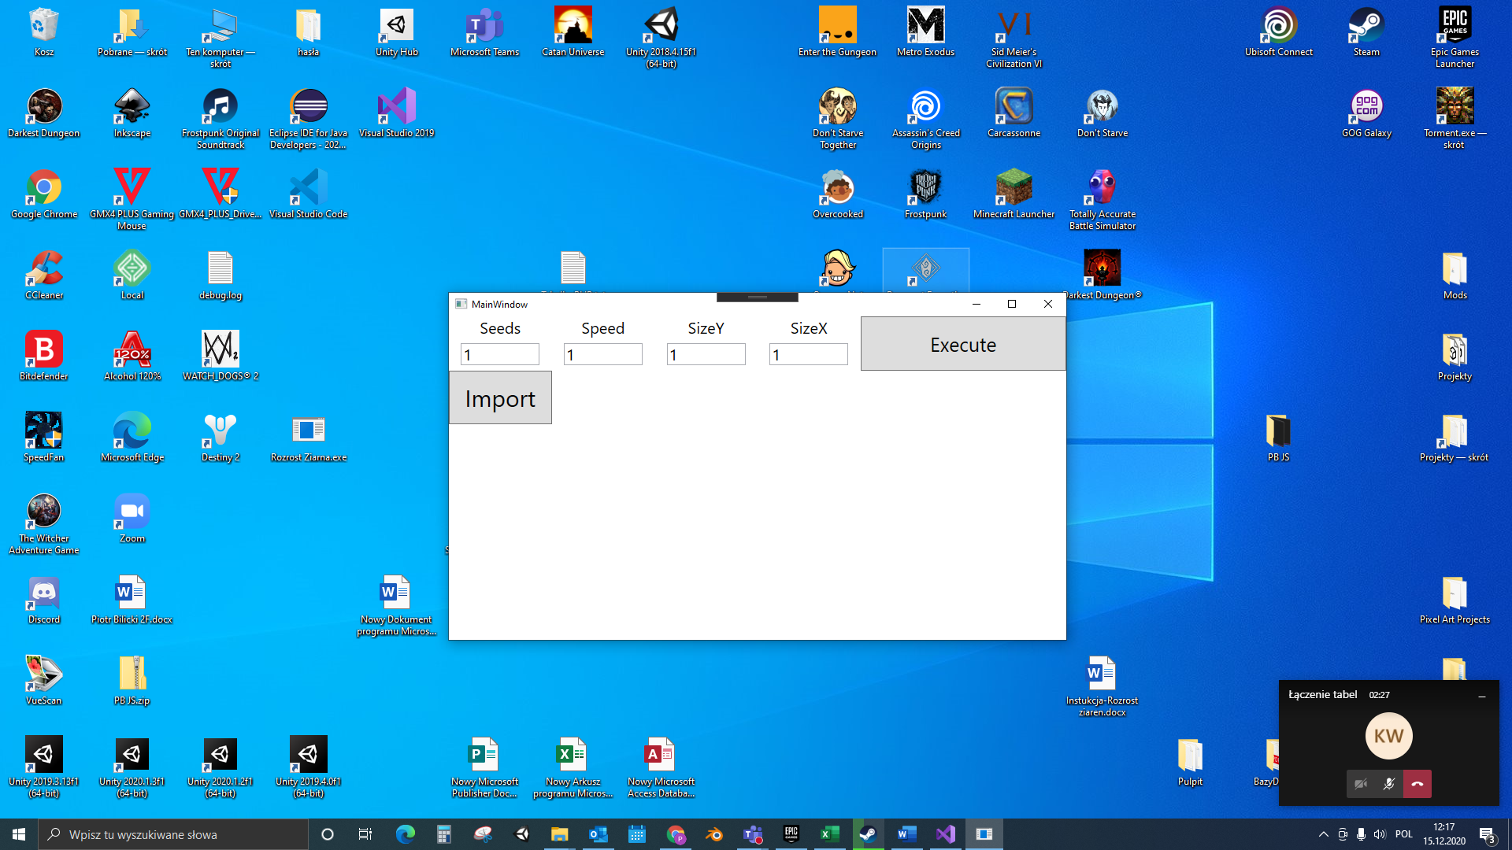
- Seeds: determines how many seeds the simulation should contain. Max: 15

- Speed: determines the speed at which seeds are spreading in the simulation. 1-fastest. Speed ​​1 is recommended for simulations with high resolution meshes.
- SizeY i sizeX: determines the resolution of the mesh in the simulation.
SizeY is the number of rows and SizeX is the number of columns.
- Execute: starts the simulation call. A new window will open with the simulation interface.
- Import: imports the previously exported simulation and displays its final result in a new window.
After pressing execute, the simulation will be started.
First, the seeds will be radomly placed on the grid. After all the seeds are set(as shown in Seeds), all seeds will begin to spread evenly.
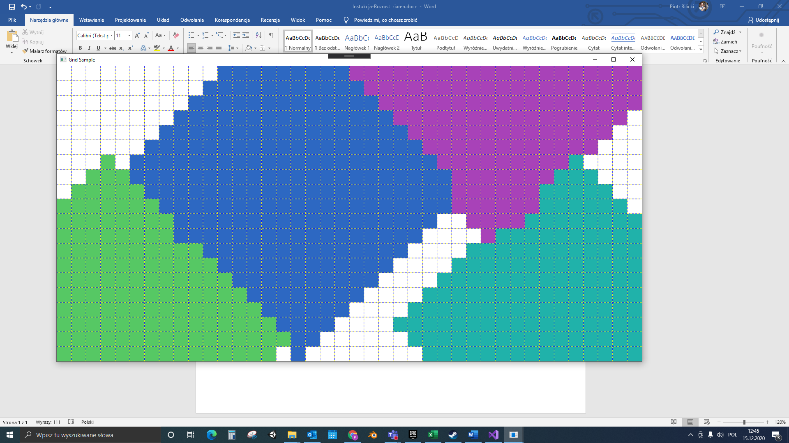
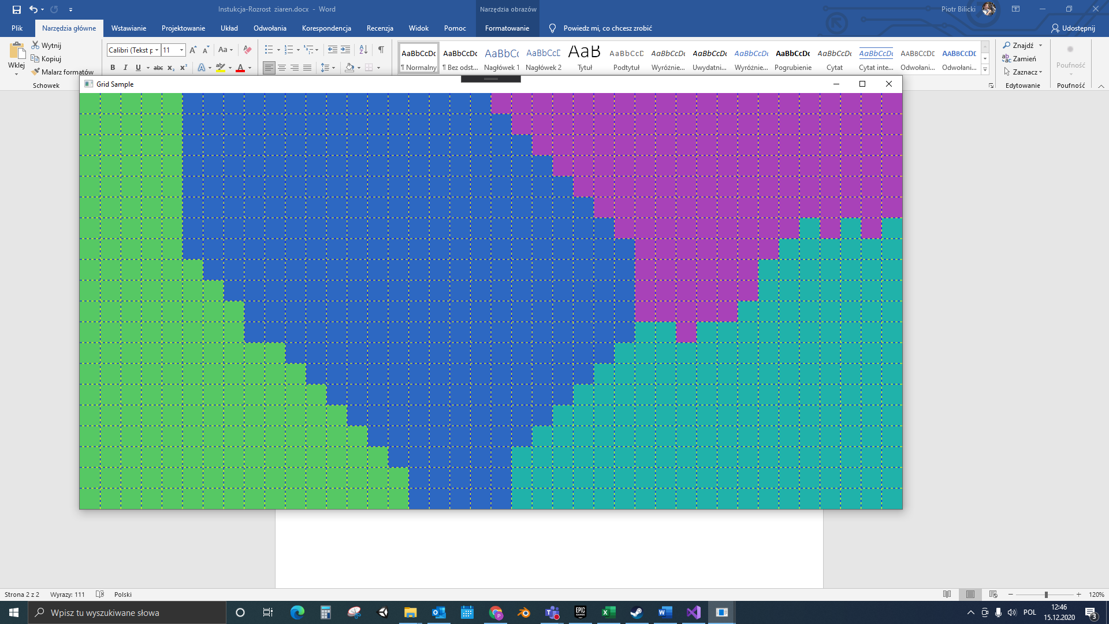

When there are no more white boxes, the program ends. Then we have the option to export the result to a txt and bmp file. If we confirm, the WriteLines.txt file will appear in the documents folder. and image.bmp.

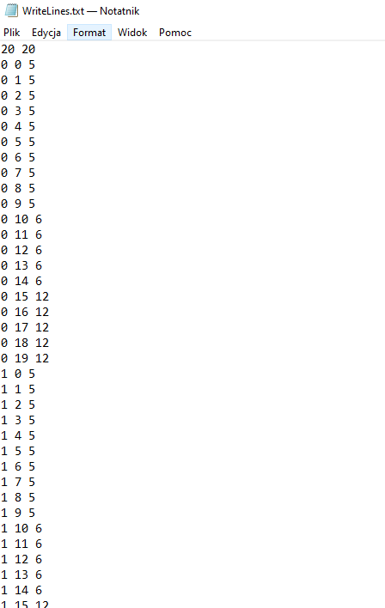
Then, if we want to import it back to the program, we have to press Import and select our WriteLines.txt file. A window will appear with the result of our simulation saved in the txt file.
Inclusions

Inclusions are areas in the simulation that do not grow, but are an obstacle to growing grains. 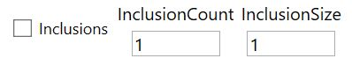
Tick Inclusions – if it is ticked , the program will take account of inclusions in cumulation

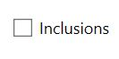
Inclusion Count
determines how many inclusions are to be in the simulation.
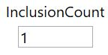
Inclusion Size determines the diameter (in fields) of the inclusions.
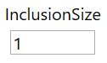
Exemplary program: Inclusion Count=3, Inclusion Size=2.
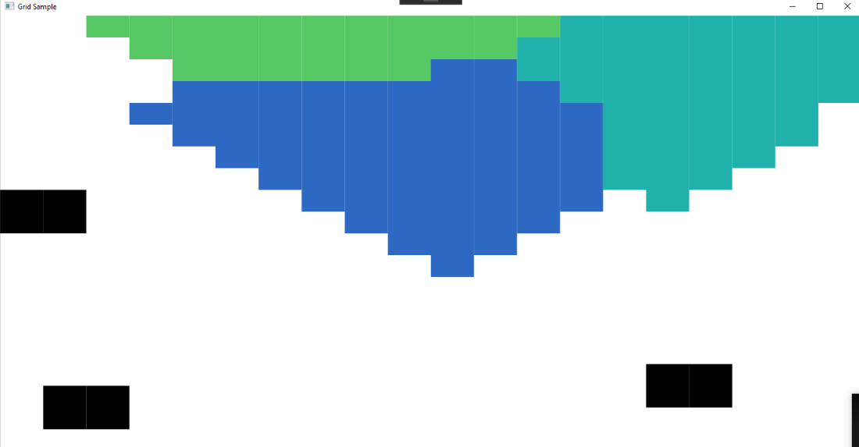
Walls

After the simulation is completed, it is possible to mark the boundaries between the grains. Then the borders are removed.
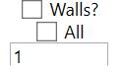

Walls check - if ticked, the program will take into account the walls in the stack.
Ticked All - if ticked, the program will mark the boundaries at the edges of all grains.
The box under All specifies, if All is unmarked, at the boundaries of which seed number the boundaries should appear.
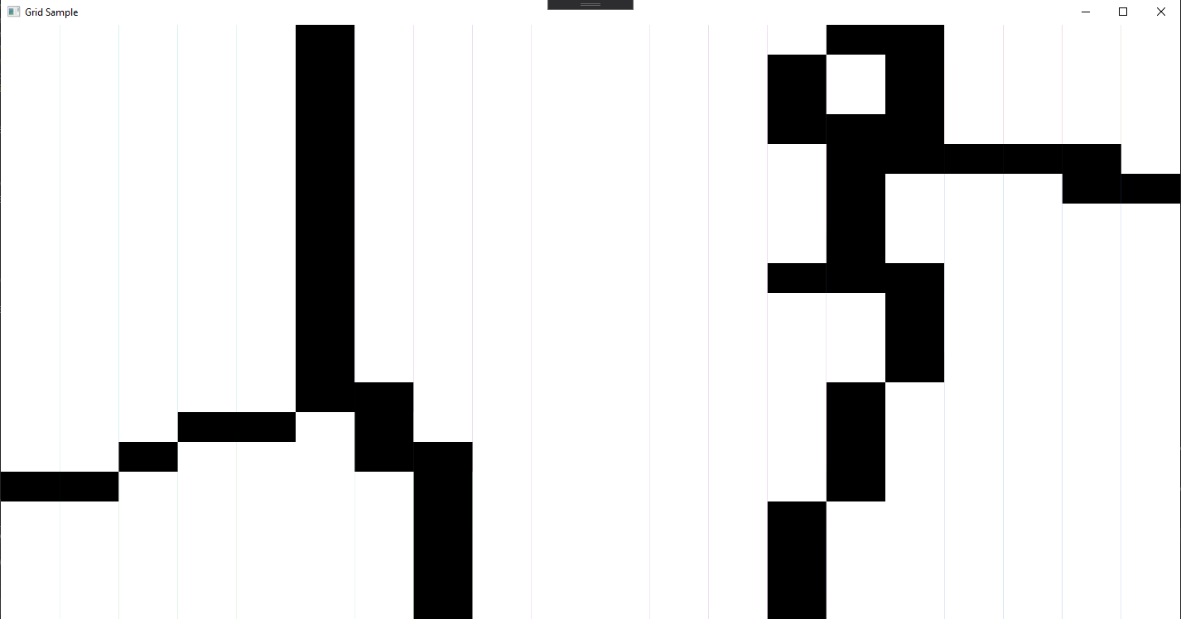

Types
The type of expansion is the way the grains are spread in the simulation.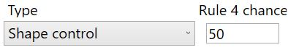
Type determines whether you want to use Von Nevman or Shape Control.
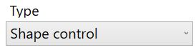
Rule 4 chence określa jaka jest szansa na rozrost w 4 zasadzie Shape Control
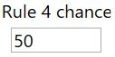
Struktury
The structures allow you to import grain from an imported project into a new simulation. The imported grain behaves like an inclusion.
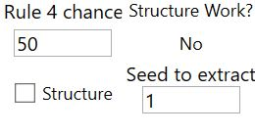
Structure Work - determines whether the execution of the structure mechanism is feasible. It becomes workable after importing the project..
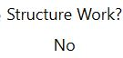
Ticked structure – if it is marked, the program will include walls in structures.
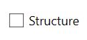

Seed to extract determines which grain number from the imported project is to appear in the simulation.

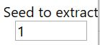
Ticked Show Gid - if marked, the program will show the mesh in the simulation. This has no effect on the operation of the program. This is only a graphic effect.

